### ­­

**Liquid Marble Wallpaper in Taupe**

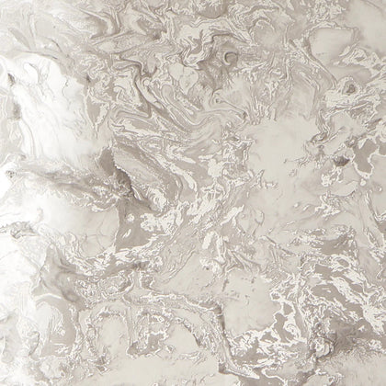Liquid marble wallpaper in taupe exudes warmth and sophistication, offering a timeless appeal for a variety of interior styles. The taupe tones, with their subtle blend of beige and grey, create a neutral yet rich backdrop that complements both modern and classic decor. The flowing, organic patterns mimic the natural elegance of marble, adding depth and texture to walls while maintaining a soft, understated aesthetic. Perfect for living rooms, bedrooms, or feature walls, this versatile design brings a refined, calming ambiance to any space.